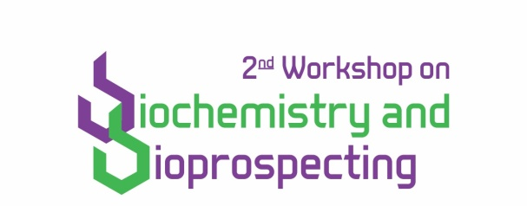

REGISTRATION FORM
PERSONAL DATA
Complete name:

Name for identification:

Institution:

Course or program:

( ) Graduate student
( ) Postgraduate student
( ) Researcher and professor
( ) Professionals and others

RG: | CPF:
CONTACT
E-mail:

Phone number:

ABSTRACT SUBMISSION
( ) YES ( ) NO
Title:

Area:
( ) Biochemistry ( ) Bioprospecting
( ) Other: ______________________________

REGISTRATION FEES
Graduate student: R$ 30,00  Postgraduate student: R$ 70,00 | Researcher and professor: R$ 150,00  Professionals and others: R$ 150,00

Send registration form, institutional enrollment certificate (for graduate and postgraduate students), abstract and payment proof of registration fee to workshopppgbbio@gmail.com

